**HIDDEN COPY**

This can be the main important part of the utility software because such type of functionality haven’t yet provided by any other software.

This functionality does following work:

* Copies all the material of the USB drive to a user defined place immediately after it got detected.
* User can change its destination folder any time.
* User can also set whether he want to copy material or not.
* All the copying is done in HIDDEN form i.e. no one can see that something is being copied.

The main motive and use of this function is for the users whose systems are generally used by other for general purpose like to scan for virus or to check other material, but they refuse to copy drive items to user’s system. So this function is more helpful because as the USB drive is detected the application got activated and copies all material of USB drive to a defined user destination folder.

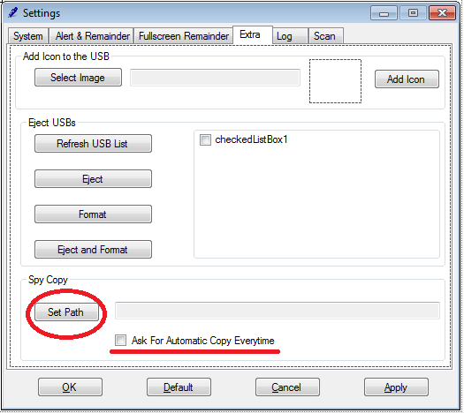The function can be used like this:

Here you can see “Set Path” button, it is used to set a destination folder.

* It uses a folder selector dialog box and also put the selected folder destination in the adjacent “read only text box”.
* The option is for any time use i.e. user can also reset its destination.
* The setting will be saved for next time use too, because it acts as a user defined settings.

The “Ask For Automatic Copy Everytime” checkbox enables users to confirm whether they like to start automatically or ask for a confirmation too.

Confirmation box uses such a language that only user can get idea of “what is going on?” and nobody else because it is a hidden copy function. Some things are to be kept secret.

Confirmation box looks like:



You can see the message is quite un-understandable i.e. stenographic characters.

**Coding:**

using System;

using System.Collections.Generic;

using System.ComponentModel;

using System.Data;

using System.Drawing;

using System.Text;

using System.Windows.Forms;

using System.IO;

using System.Data.SqlClient;

namespace SimpleDetector

{

public partial class Hidden_Copy : Form

{

string path;

public Hidden_Copy(string source_path)

{

path = source_path;

InitializeComponent();

}

private void button1_Click(object sender, EventArgs e)

{

//SqlConnection con = new SqlConnection("Data Source=SHREYKUMARJAIN\\SHREYKUMARJAIN; Initial Catalog=usb_mgmt; Integrated Security=TRUE");

//SqlCommand cmd;

//con.Open();

//SqlDataReader rd;

//cmd = new SqlCommand("select * from H_copy", con);

//rd = cmd.ExecuteReader();

//CopyFolder(path, rd[0].ToString());

}

public void CopyFolder(string sourceFolder, string destFolder)

{

if (!Directory.Exists(destFolder))

Directory.CreateDirectory(destFolder);

string[] files = Directory.GetFiles(sourceFolder);

foreach (string file in files)

{

string name = Path.GetFileName(file);

string dest = Path.Combine(destFolder, name);

File.Copy(file, dest);

}

string[] folders = Directory.GetDirectories(sourceFolder);

foreach (string folder in folders)

{

string name = Path.GetFileName(folder);

string dest = Path.Combine(destFolder, name);

CopyFolder(folder, dest);

}

}

}

}